OmniSearch: An Offline Multimodal Retrieval-Augmented Generation Platform for Cross-Domain Document Intelligence
Arnab Kundu
23BCE5013

Abstract—Information is today found in all kinds of document types, such as textual reports in PDF and DOCX format, photos and diagrams in PNG and JPEG format, and audio data from discussions or seminars. A challenge that persists in most systems today is the inability to search for information in these various formats seamlessly. The problem is exacerbated when cloud computing is not an option due to privacy issues. This is where OmniSearch helps because it has the ability to be run in an offline and locally-hosted manner where documents, photos, and audio can be indexed in one place and queries asked to the LLM. The backend of the application is developed in Node.js, incorporating TypeScript and Express frameworks, whereas the frontend is designed as a lightweight, single-page app that uses HTML, CSS, and JavaScript. In terms of data storage, the application combines SQLite for managing structured metadata about files and cross-modal associations with ChromaDB, which is used for storing vector embeddings and organizing them into different col- lections based on modalities. All the AI computations, including embedding text using nomic-embed-text, generating languages using Llama 3.1 8B, and describing images using LLaVA, are performed in Ollama locally on the user’s computer without any information being uploaded online. The Reciprocal Rank Fusion retrieval layer is another key point that combines the retrieved documents from all three modalities and produces a unified ranked list for further processing by the LLM. Semantic links between documents of various types are discovered automatically and logged as cross-modal relations. Currently implemented, the system includes the entire workflow from uploading documents to retrieving from multiple collections, Reciprocal Rank Fusion, generating output by the LLM with numeric references, and an admin panel.
- Project Title
OmniSearch: An Offline Multimodal Retrieval-Augmented Generation Platform for Cross-Domain Document Intelligence
- Background
The Retrieval-Augmented Generation approach, abbreviated as RAG, has emerged as one of the most widely utilized approaches within AI applications during recent years. Instead of depending on the language model’s parameterized memory, which might be out-of-date, inaccurate, or even hallucina- tory, RAG systems anchor their outputs to evidence retrieved from a particular corpus. Generally, the procedure entails the following steps: conversion of the user’s input question to an embedding vector, comparison of the vector against an existing database of document excerpts, and inclusion of the most pertinent excerpts within the prompt context prior to generating an output by the LLM. This pattern has been tested
within multiple projects such as LangChain, LlamaIndex, and commercial products, but all of these solutions suffer from some common drawbacks, prompting the creation of this project.
The first problem with RAG is that most solutions are text-based only. They work fine with PDFs and other textual formats but completely disregard images, diagrams, and audio files. However, in practice, quite a lot of valuable data can be found in the form of images like charts and architecture diagrams, or audio files like lectures and meeting minutes. This makes using images and audio files pointless.
The second issue relates to the availability of cloud services. Almost every RAG solution requires access to cloud storage to store embeddings and generate new data. This makes no sense from an academic research perspective or when handling sensitive data like medical records or legal documents.
Thirdly, even open-source self-hosted solutions have signifi- cant infrastructure prerequisites like Kubernetes, Redis, Celery workers, and PostgreSQL, making it hard to deploy it locally for one person or even a few people.
OmniSearch is a solution developed in response to the problems discussed above. The idea behind OmniSearch is to develop a multimodal RAG system that will be deployed offline, process various data types, and have low infrastructural requirements, allowing students to deploy this model from their laptops.
- Proposed System
- Core Contribution
The primary contribution of OmniSearch is the unification of three separate content modalities – text, image, and audio – into a single retrieval-and-generation pipeline, running entirely offline. While individual components such as vector databases, local LLMs, and embedding models exist as standalone tools, the novelty lies in combining them into a coherent multimodal RAG workflow with cross-modal linking, RRF-based result fusion, and a streaming answer interface.
- How OmniSearch Differs from Existing Work
- Workflow Description
The system follows a two-phase design – Ingest and Query.

Ingest Phase:
1) The user will upload files by dragging and dropping files on the frontend interface. File validation is performed

TABLE I
Comparison of OmniSearch with Typical RAG Tools

Aspect Typical RAG Tools OmniSearch
Modalities Text only Text + Image + Audio
- Originality
The innovations involve three particular domains:
  - Multimodal vector search with the help of the RRF fusion technique: one query can result in a PDF paragraph,

Deployment Cloud-hosted (GPT-4, Pinecone, etc.)
Infrastructure Redis, PostgreSQL,
Kubernetes
Fully local (Ollama, ChromaDB, SQLite) Zero external infra – single Node process
image description, and speech transcript, all placed on a ranking list.
  - Semantic links between content pieces in different modal-

Cross-modal linking
Not supported Automatic semantic link detection
ities automatically detected and stored by the system
following any ingestion session.

Result fusion Single-collection re-
trieval
Reciprocal Rank Fu- sion across three col- lections
  - Totally offline, no cloud, and low infrastructure require- ments setup, with everything running from a single pro-

Streaming Varies SSE-based real-time token streaming

using Multer middleware to check file types and set file sizes (500MB per file; 20 files per request).
- A metadata record is created in SQLite with status ‘queued’ and a UUID primary key.
- Based on their mime type, files are sent for extraction to different tools: PDFs will be extracted page-wise using pdf-parse, maintaining the page numbers intact; DOCX files will be transformed into text format using mammoth; images will be downsized to 768 pixels at most using sharp, while LLaVA 7B is used for the captioning process.
- The extracted text is segmented into overlapping seg- ments with a sentence boundary aware sliding window of size 512 with an overlap of 64 words.
- Each segment is embedded using nomic-embed-text through the Ollama local API.
- The embeddings, along with metadata such as file ID, chunk ID, page number, character offsets, and modality label, are inserted into the relevant ChromaDB collec- tion.
- Cross-modal detection entails embedding sample text and searching across other modality collections. Any- thing that exceeds cosine similarity 0.75 is stored as a cross-modal link in SQLite.

Query Phase:
- The query input is given by the user with a selection of the modality types included.
- The nomic-embed-text function encodes the query string.
- Each ChromaDB collection takes the query embedding, returning the top-K neighbors (by default K=10).
- All neighbor collections get merged using Reciprocal Rank Fusion with a smoothing factor of k=60.
- The prompt builder creates context chunks based on the order of RRF scores until reaching the 4096 token limit.
- The prompt gets sent to Llama 3.1 8B by Ollama’s streaming API.
- Tokens get streamed to the frontend through Server Sent Events.
cess (Node.js), an SQLite database, and two additional locally operating services: ChromaDB and Ollama.
- System Architecture
The architecture follows a three-tier pattern – presentation, application, and data – adapted for a multimodal RAG work- load.
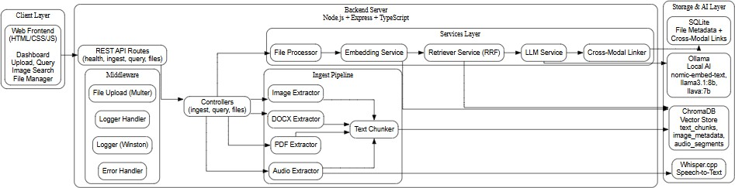

Fig. 1. OmniSearch System Architecture Diagram

- Presentation Tier (Frontend)
The single page application comprises three static files: index.html, styles.css, and app.js. The GUI contains six tabs that include the dashboard (statistics and system service health information), upload (file uploading via drag-and-drop with progress tracking), ask (query with server-sent-event streamed response), image search (visual cross-modal search), files (manage the files using paginated display), and links (rela- tionship between objects with cross-modal interface). For all interactions on the backend side, Fetch API has been used, where for file upload, FormData is utilized, and queries with JSON POST requests.
- Application Tier (Backend)
Node.js with TypeScript & Express application server hav- ing an internal layered architecture:
  - Routes layer: four route modules (health, ingest, query, files) map HTTP routes to the corresponding controllers.
  - Controllers layer: three controllers responsible for busi- ness logic implementation for file-related operations, in- gestion, and queries with validation by means of Zod.
  - Services layer: six services implementing embedding generation, vectors manipulation, retrieval & RRF fusion, LLM streaming, cross-modal links detection, and orches- trating file processing logic.
  - Ingestion sub-layer: five specialized extractors (PDF, DOCX, image, audio, and text chunker) that provide specific content extraction logic.

  - Middleware layer: typed error handling, logging, and files uploading middleware.
  - Configuration: environment variables are validated dur- ing app start-up with the help of Zod; configuration constants related to supported MIME-types and text chunking.

- Data Tier (Storage and AI)
  - SQLite: Two tables: files (metadata, status of process- ing, chunks count) and crossmodallinks (relationships between data). Accessed using Knex.js with write-ahead logging.
  - ChromaDB: Three HNSW collections: textchunks, im- agemetadata, and audiosegments with cosine similarity.
  - Ollama: Three local models: nomic-embed-text (embed-
B. Dataset / Test Files
The system was tested with a mixed corpus of files across all four supported types:
- PDF documents – academic papers, lecture slides, and technical reports of various lengths
- DOCX files – meeting notes and assignment documents
- Images – screenshots of charts, diagrams, and pho- tographs (PNG, JPG, WEBP)
- Audio – recorded lecture segments and voice memos (MP3, WAV)
C. Configuration Parameters

TABLE III
Configuration Parameters

dings), llama3.1:8b (answer), llava:7b (caption images).

- Whisper.cpp: External binary used for transcribing audio data, executed as a child process.
Parameter Default Description

CHUNK SIZE 512 Target words per text chunk CHUNK OVERLAP 64 Words to overlap between

- Protocol Stack
The communication protocol stack for OmniSearch consists of the following layers. The frontend communicates with the
TOP K 10
MAX CONTEXT TOKENS4096
consecutive chunks Number of nearest neigh- bours per collection Maximum tokens in the LLM prompt context

backend over HTTP/1.1 using the Fetch API. File uploads
LLAVA MAX DIM 768 Max pixel dimension for

use multipart/form-data encoding via Multer. Query responses use Server-Sent Events (SSE) over HTTP POST for real-time
SIMILARITY THRESHOL0D.75
images sent to vision model Minimum cosine similarity for cross-modal links

token streaming. The backend communicates with Ollama over HTTP REST (JSON) for embeddings, LLM generation, and vision model inference. ChromaDB is accessed via its HTTP REST API (v2) for vector upsert, query, and delete operations. SQLite is accessed locally via the Knex.js query builder using file-based I/O. Whisper.cpp is invoked as a child process via stdin/stdout pipes.

- Testbed / Experimental Setup
A. Software Stack

TABLE II
Software Stack

Tool Version Purpose

Node.js 18+ Backend runtime
TypeScript 5.3.x Type-safe backend development Express.js 4.18.x HTTP server and routing
SQLite3 5.1.x / 3.1.x File metadata and cross-modal links ChromaDB Latest Vector database with HNSW indexing Ollama Latest Local LLM and embedding inference nomic-embed-text – 768-dimensional text embeddings llama3.1:8b – Language generation (8B parameters) llava:7b – Vision-language model for image cap-
RRF K 60 Smoothing constant for Re- ciprocal Rank Fusion

- 100% Implementation
This segment explains all the implemented features of OmniSearch and provides code snippets from the real source files, screenshots of the live application, and analysis. This implementation uses 29 backend source files, which include Node.js along with TypeScript, and 3 frontend files, which are HTML, CSS, and JavaScript.
- Backend Server Startup and Environment Validation
The point of entry is server.ts which imports the Express app from app.ts and starts listening on the spec- ified port (default 3001). Before accepting any request, the Zod environment validation in config/env.ts reads all environment variables and ends the program with an in- formative error if there is no required variable or if its type is incorrect. In app.ts, CORS, JSON body parsing up to 10MB, Morgan HTTP requests logging and mount- points for the four routes: /api/health, /api/ingest,

Whisper.cpp base.en
tioning
Audio transcription
/api/query and /api/files are set up. Automatic

sharp 0.33.x Image resizing and format conversion
pdf-parse 1.1.x PDF text extraction
mammoth 1.7.x DOCX to plain text conversion Multer 1.4.x Multipart file upload handling
Winston 3.12.x Structured logging (console + file)
Zod 3.22.x Runtime schema validation
Axios 1.6.x HTTP client for inter-service communi- cation
SQLite migrations are performed by the system: tables ’files’ and ’crossmodallinks’ will be created if they don’t exist, write-ahead logging is activated and foreign keys constraints will be enforced. ’uploads/’ and ’logs/’ directories are created if they don’t exist. Console and file transport Winston log- gers are created. Handlers for graceful shutting down of the application on SIGTERM and SIGINT are established.

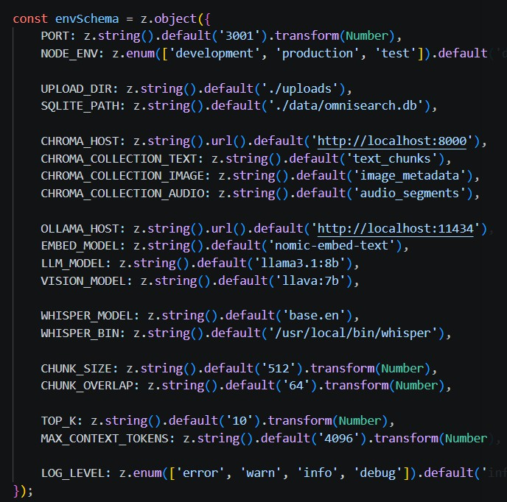
Fig. 2. Environment configuration file (config/env.ts) showing Zod schema validation for all environment variables including port, database paths, Chro- maDB and Ollama hosts, model names, and chunking parameters
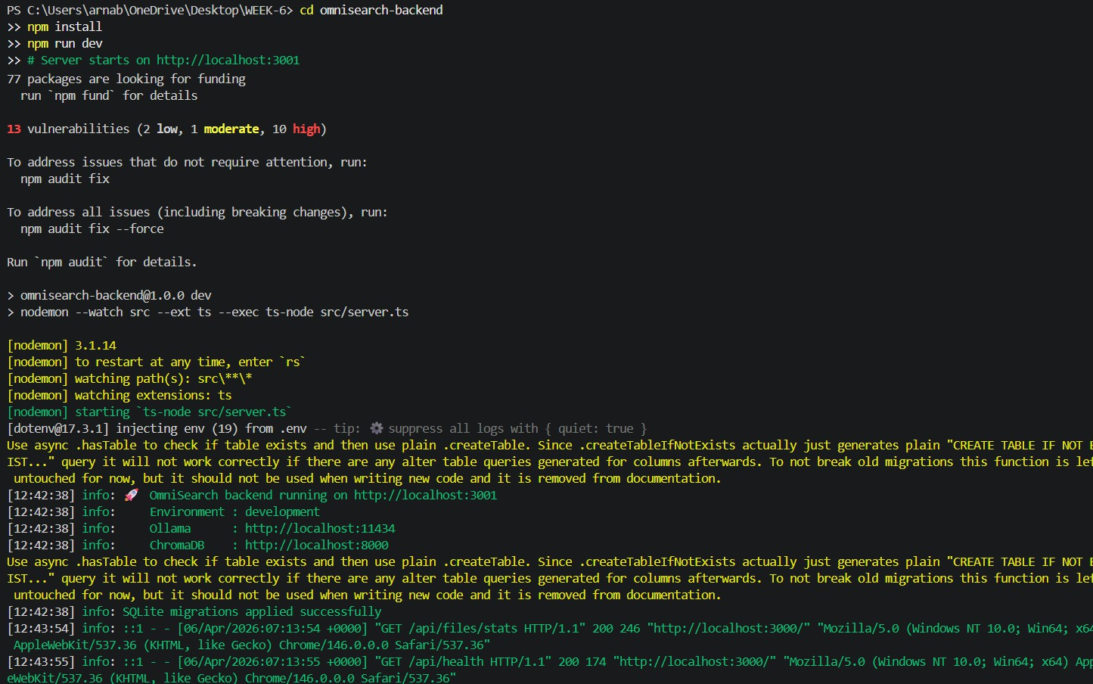

Fig. 3. Backend server startup in terminal showing SQLite initialisation, ChromaDB and Ollama connection confirmation, and health check results

Observation analysis: Environment verification during sys- tem startup as opposed to the initial use guarantees that any incorrect CHROMAHOST URL causes the server to fail to launch with an error message, instead of crashing without an error message during the first request after ten minutes of usage. This is particularly advantageous when setting up the environment on a new machine without Ollama or ChromaDB.
- File Ingestion Pipeline
The most complex sub-system is the ingestion pipeline, which is coordinated using processor.ts. When a POST request is sent to /api/ingest, including one or multiple files, the Multer library inside upload.ts checks that the
file MIME type matches one in the list of acceptable types (PDF, DOCX, PNG, JPEG, WEBP, MP3, WAV, M4A) while
also checking that its size does not exceed 500MB, and saves the file on disk under a UUID filename. Meanwhile, the ingestion controller (ingest.controller.ts) inserts a record into the SQLite DB with status ‘queued’ and starts processFile() in the background.
The processFile() function defined in the processor.ts script channels the respective files to their dedicated processors: the processPdf() processor parses texts page by page from PDF using pdf-parse and feeds each of them to the chunker, processDocx() transforms DOCX to plain texts using mammoth, processImage() resizes the images to a maximum of 768 pixels using sharp, encodes them to base64 and calls LLaVA 7B hosted on Ollama to generate captions, while processAudio() invokes a child process running Whisper.cpp with a time limit of 10 minutes, which will parse either JSON or SRT formats into segments with timestamps.
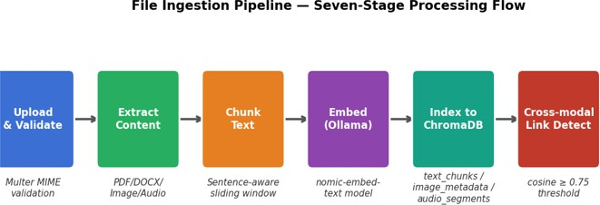

Fig. 4. Seven-stage file ingestion pipeline from upload to cross-modal link detection

The chunker from chunker.ts uses a sliding win- dow approach to segment the extracted text with awareness of sentence boundaries. Sentence delimiters are sentence- ending punctuation characters with trailing whitespace. Chunks are generated when the total number of words equals CHUNK_SIZE (defaults to 512), while chunks keep CHUNKOVERLAP (defaults to 64) words from the previous chunk to ensure continuity. In case of PDF documents, the chunkPages() method performs operations on each indi- vidual page.
Analytical observation: The asynchronous process- ing model (fire-and-forget from the controller, poll via
/api/ingest/:id/status) keeps the API responsive even for large PDFs. The frontend polls every 2 seconds and updates progress cards in real time. A 30-page PDF typically completes in 15 to 25 seconds depending on CPU speed and chunk count.
- Multi-Modal Retrieval and RRF Fusion
The retrieval engine, in retrieval.service.ts, spreads the query vector across all chosen ChromaDB col- lections in parallel with Promise.all(). Each collection returns their best K results based on cosine similarity. The fuseResults() method uses Reciprocal Rank Fusion, whereby the RRF value 1/(60 + r) is calculated for every

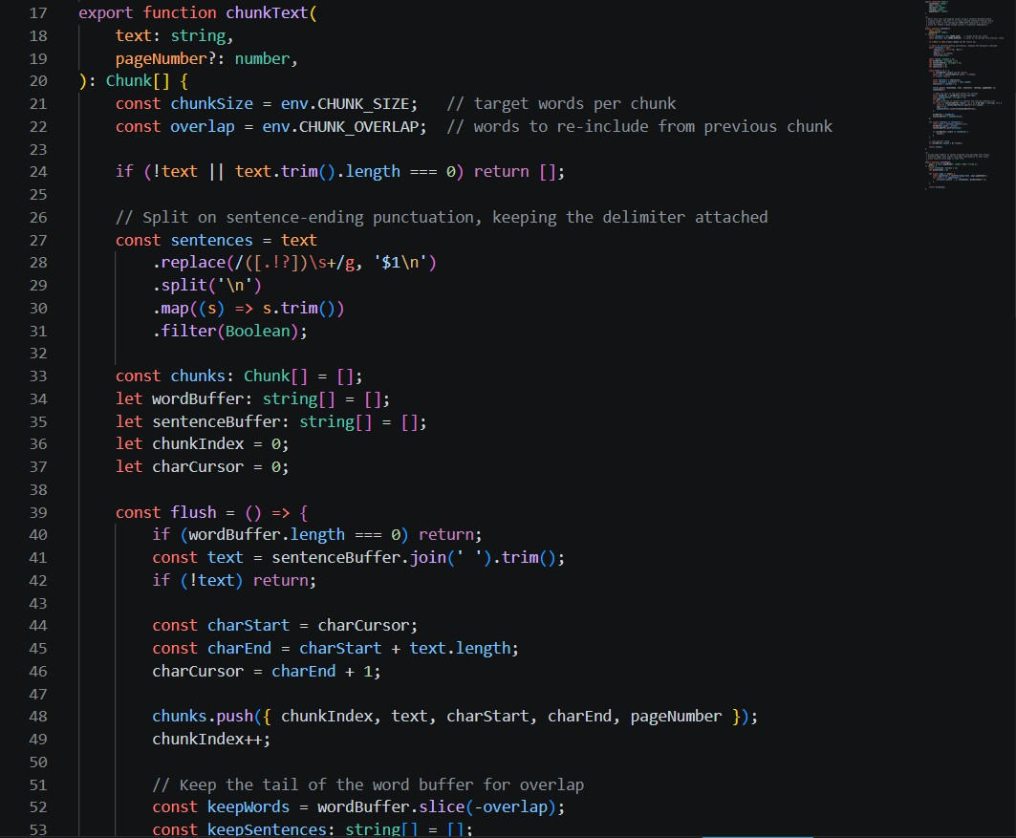

Fig. 5. Chunker implementation (chunker.ts) showing the sentence-boundary- aware sliding window algorithm with configurable CHUNK SIZE and CHUNK OVERLAP parameters
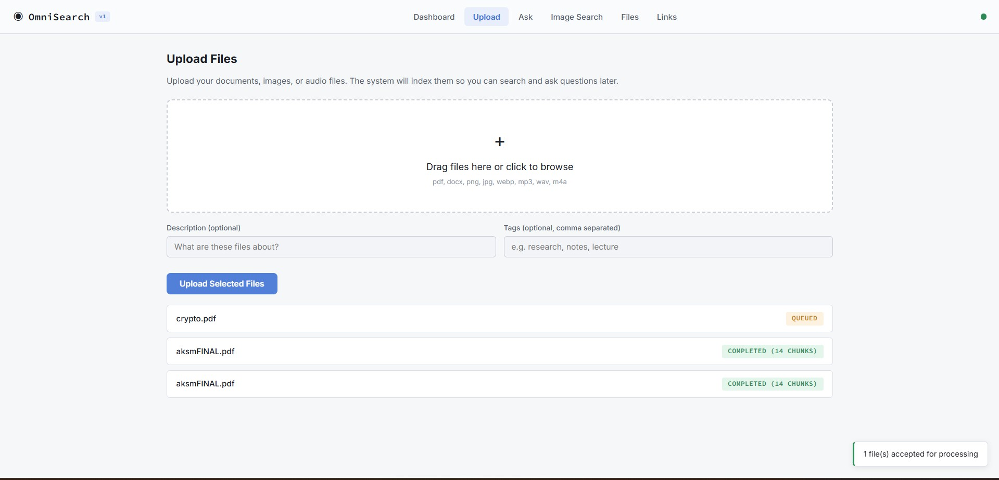

Fig. 6. File upload interface with drag-and-drop zone, optional metadata fields (description, tags), and real-time progress tracking cards showing queued, processing, and completed statuses with chunk counts

result at position r in each modality and accumulated. The sum of RRF values for any document in several modalities increases its likelihood to be relevant. The fusion process ends with sorting the result set in the decreasing order of the RRF scores. Cross-modal links are found from SQLite through the method getLinksBySourceFile().
Observations on Analysis: The RRF technique is proven for combining ranked lists where calibration or normalization of scores is not required. The value of k=60 for smoothing comes from the recommendation of Cormack et al. (2009). The major benefit in this particular case is that cosine distances returned by ChromaDB can be used directly as they don’t require normalization between the corpora.
- LLM Answer Generation With Stream
The prompt generator in the prompt.builder.ts file constructs the context by formatting each chunk as a numbered block with details about the source file name, mode, and loca- tion (page number in case of textual information, timestamp in

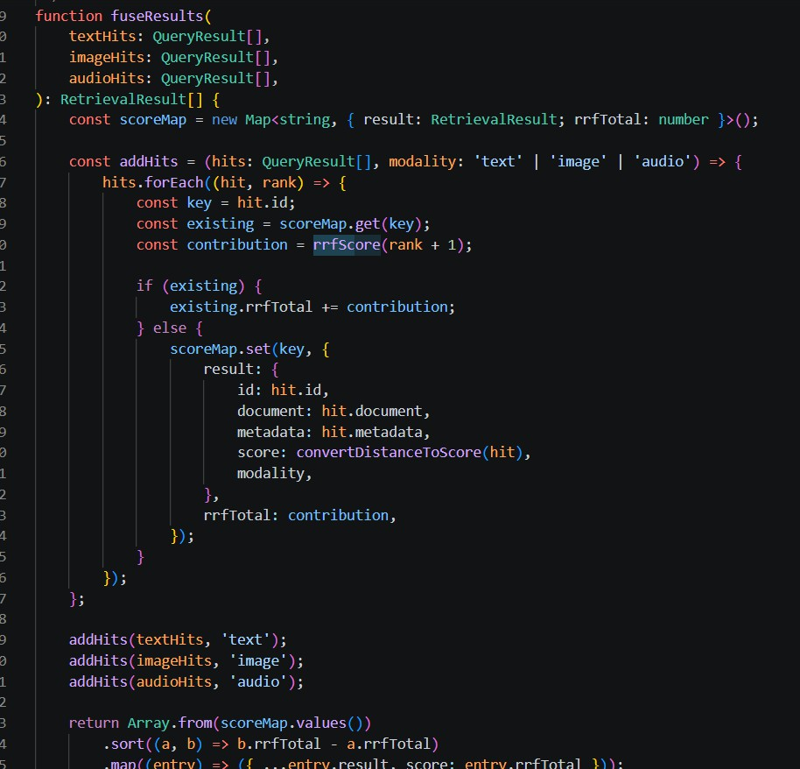
Fig. 7. Retrieval service implementation (retrieval.service.ts) showing the Reciprocal Rank Fusion algorithm with rrfScore() function and fuseResults() merging text, image, and audio hits into a unified ranked list
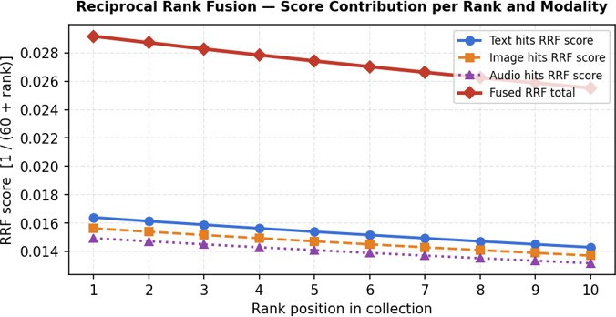

Fig. 8. RRF score curves per rank position for each modality – k=60 smoothing constant flattens score differences between adjacent ranks

case of audio data, and dimension in case of image content). These chunks are added to the context one after another in the order of their RRF score till the 4096-token budget is exhausted. The budget is maintained using a word-to-token ratio (1.3 tokens/word).
This assembled prompt is delivered to the Ollama
/api/generate API with stream: true through the LLM service in llm.service.ts. Ollama provides new- line delimited JSON, where each line has a ‘response’ field and a ‘done’ boolean field. This output stream is then consumed line-by-line by the LLM service which trig- gers the onToken callbacks. These callbacks are trans- formed to server-sent events in query.controller.ts as follows: ‘context’ with extracted chunks, ‘token’ with the LLM tokens, ‘citations’ with source citations generated in citation.builder.ts, and ‘done’ with usage stats for context chunks extracted, chunks discarded, and number of

tokens in response.
On the frontend, the Ask tab uses a manual ReadableStream reader via fetch().body.getReader() to process the SSE stream. The browser’s native EventSource API only supports GET requests, so the manual reader is used to enable POST with a JSON body. Tokens are appended to the answer display in real time with auto-scrolling.
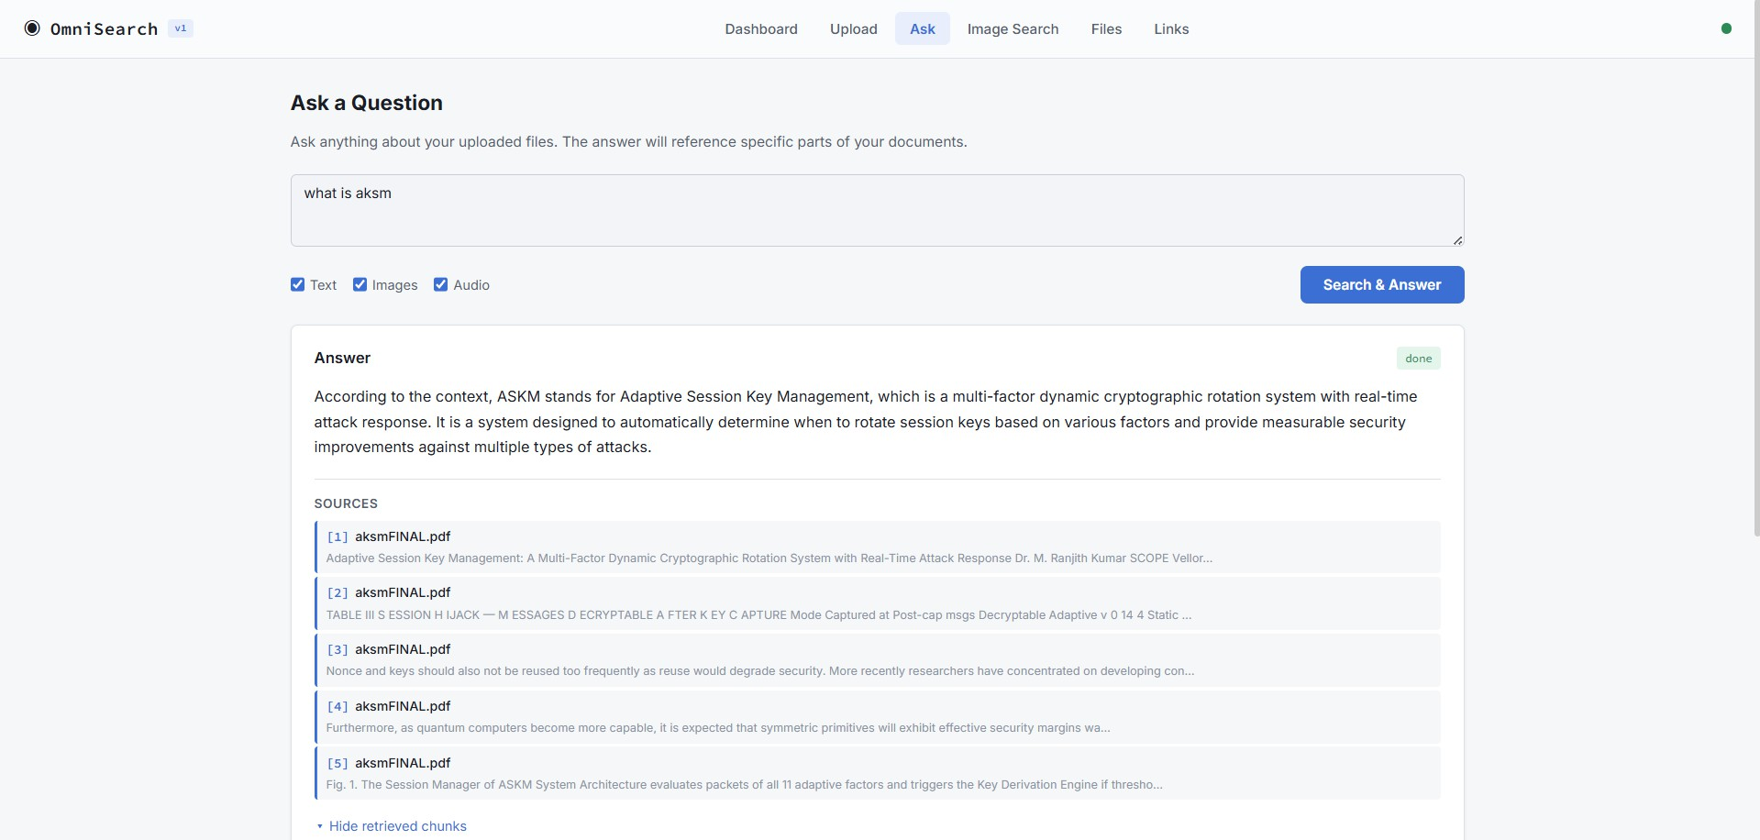

Fig. 9. Natural language query interface with real-time SSE streaming response and numbered citations

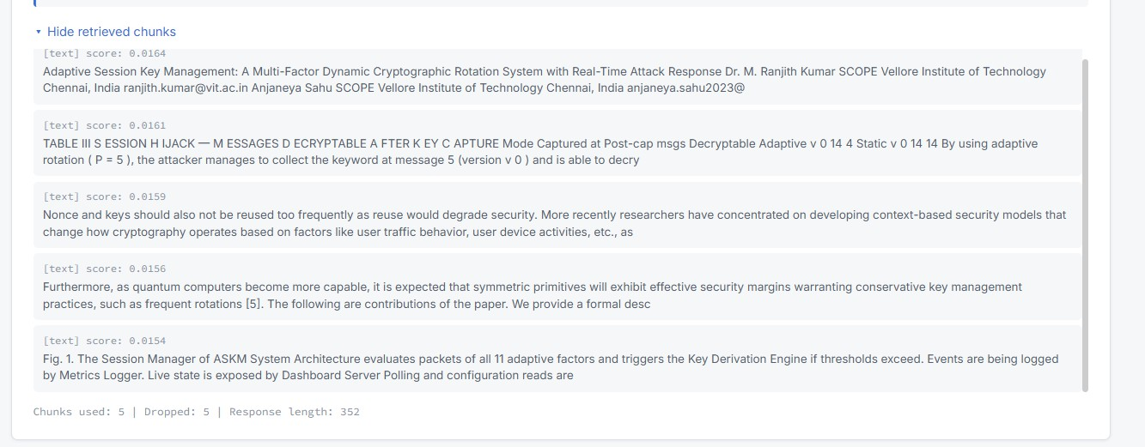

Fig. 10. Retrieved context chunks displayed with RRF scores and source metadata after query completion

Observation of analysis: A manual read streamer for SSE in POST is an intended solution. The manual read streamer offers equal streaming performance with the ability to use any HTTP method or add additional HTTP headers. The ‘done’ event statistics will show if the complete context could be included within the token limit or not.
- Image Search (Cross-Modal Visual Query)
Under Image search, the user can upload an image for the search engine to fetch semantically similar content in all formats. On the frontend, there is a designated area where the user can drag and drop an image to preview. Upon submission, on the backend side, the function handleImageQuery() in query.controller.ts processes the image using the im- age caption generation pipeline in image.extractor.ts. This process involves resizing the image using sharp at a maximum of 768 pixels with resizeAndEncode(), en- coding the image as base64, and sending it through Ollama’s
/api/generate API endpoint for LLaVA 7B with the following prompt: “Describe this image in detail. Describe any text, objects, people, charts, diagrams, or anything else
that you see in the image.” The caption will then be embedded using nomic-embed-text, and the query will be executed on all three ChromaDB collections.
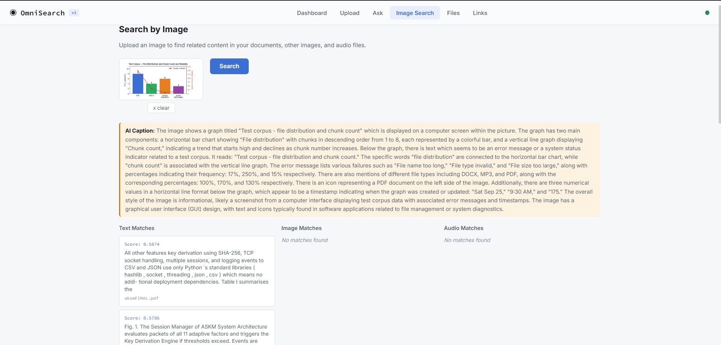

Fig. 11. Cross-modal image search – uploading a chart image returns related text paragraphs and audio segments

Observations: This is a good example of how the cross- modal bridge works. The screen shot of the chart (visual) may trigger the paragraph found in an annual report file (text) and an audio clip of the board meeting discussion (audio) about the same set of data. This will never happen with text-based RAG system alone.
- File Management and CRUD Operations
CRUD operations for the Files tab have been covered using seven endpoints provided by the files.controller.ts and files.routes.ts. Listing the files by sending a GET request to /api/files results in a paginated output (with configurable limits, default 15 on frontend) that can be filtered based on the file type (PDF, DOCX, Image, Audio) and processing state (Completed, Processing, Queued, Failed). The table contains columns showing the file name, type badge (with colored icons for the types: red - PDF, blue - DOCX, orange - Image, purple - Audio), file size, status badge, chunks, and date of upload.
By clicking on the file name, a slide-out panel appears, listing all details of the file (including its unique identi- fier, MIME type, size, whether it was processed success- fully or not, the number of indexed chunks, description, tags, and error message if there was any failure, along with timestamps). The details page also makes a call to GET
/api/files/:id/chunks API endpoint, which retrieves
all indexed chunks of the selected file from the ChromaDB database using the file ID filter.
Download using GET /api/files/:id/download delivers the raw file from the disk using the correct con- tent types and content disposition headers. Deletion through DELETE /api/files/:id occurs in a structured four-step process: first, vectors stored in the ChromaDB collections will be deleted based on fileId; second, any cross-modal links associated with this file as the source/target will be removed from SQLite; third, the file will be unlinked from the disk; and finally, the file record in SQLite will be deleted.
Statistics can be fetched using GET
/api/files/stats. This includes the number of

files, total disk usage, total number of chunks indexed, and cross-modal links, separated by type.
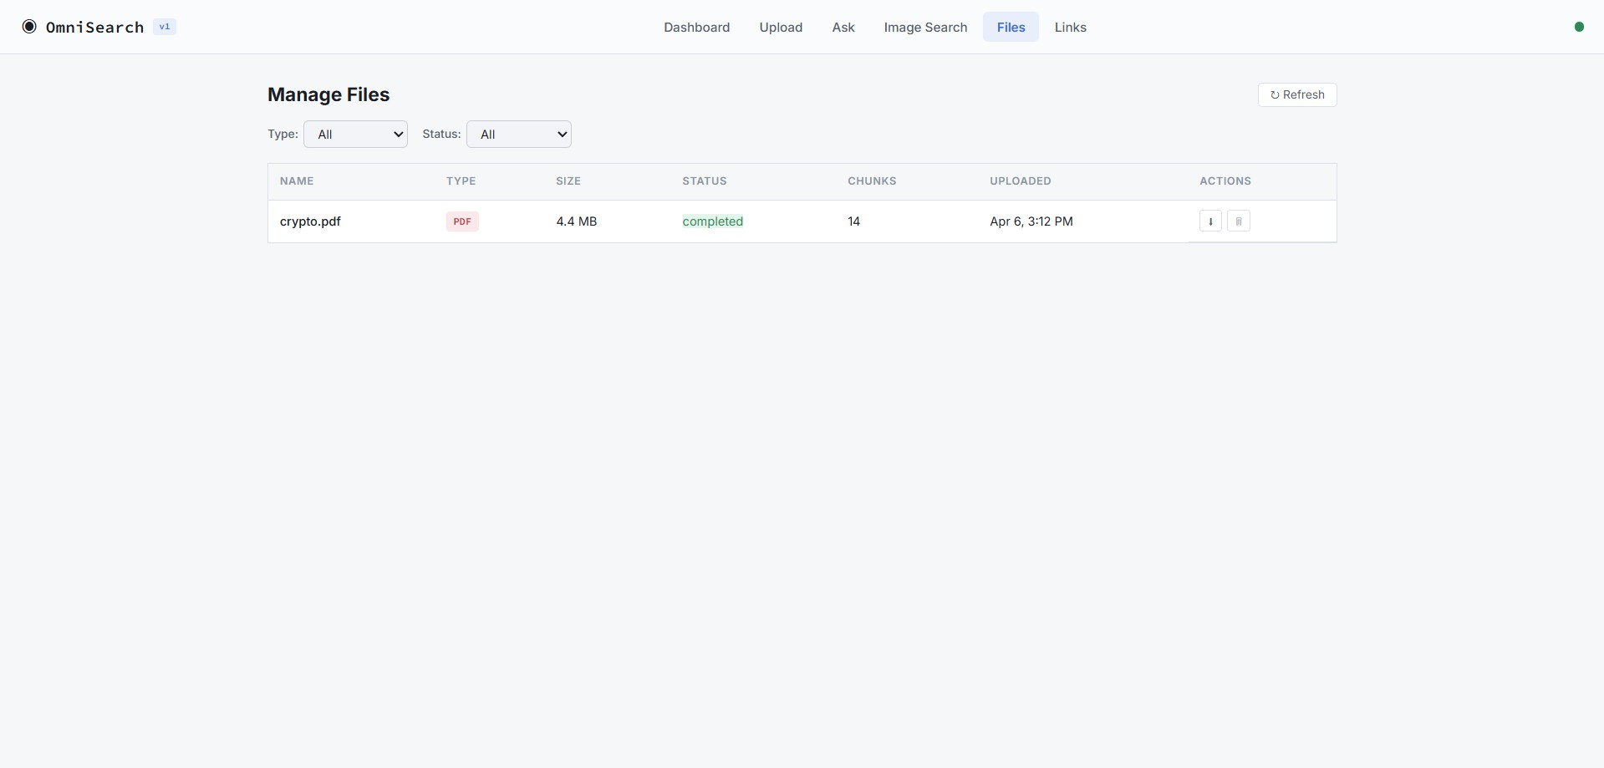

Fig. 12. File management interface with paginated listing, filters, and slide- out detail panel

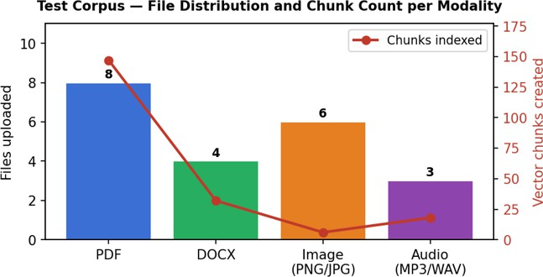

Fig. 13. Test corpus file distribution (bars) and chunk count per modality (line) from /api/files/stats output

- Dashboard and Service Health Monitoring
The Dashboard tab is the default landing page of the application and serves as a summary view of the entire system. It starts off by displaying four stat cards on the top portion of the dashboard namely: Total Files, Disk Usage (in MB), Number of Chunks Indexed, and Cross Modal Links. All the above cards are obtained using GET
/api/files/stats. Following the stat cards below, there will be a file types section where chips will be displayed
for different file types with their respective sizes and chunks indexed. There is also a section for Vector Collections contain- ing three cards namely: TextChunks, ImageMetadata, and AudioSegments, Chroma DB collection count.
Service Health calls GET /api/health that concur- rently checks ChromaDB (ping), Ollama (get tags), and SQLite (SELECT 1) using Promise.all(), which returns their status (ok/degraded), response time (milliseconds), and errors. It renders the data into three cards in a row format with coloured status dots (green for ok, red for degraded). A status dot persists in the top-right header bar to keep the user informed about the status of the system without having to navigate to the Dashboard tab. If any one of the services is degraded, the dot changes its color to orange, and the

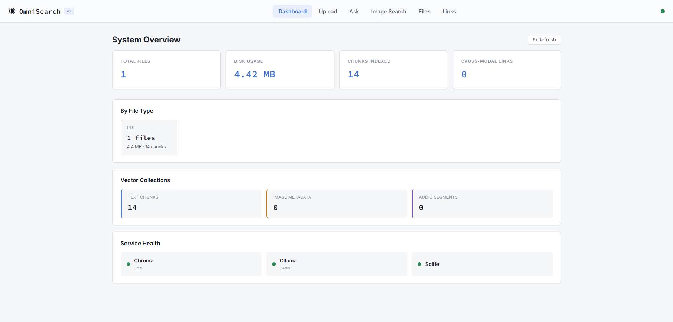

Fig. 14. Dashboard with system statistics, file type breakdown, vector collection counts, and live service health monitoring

corresponding service card displays an error message (e.g., “connect ECONNREFUSED 127.0.0.1:11434”).
Analytical observation: The degrading /api/health endpoint makes it clear what service is unavailable and the reason for it. This is more valuable compared to a generic 503 error when performing a query because the user can quickly identify if they should start Ollama or ChromaDB services.
- Query Latency Analysis
The end-to-end latency of the query was estimated by measuring the individual stages of the pipeline using Node.js Date.now() timestamps. The most time-consuming step by far is the LLM streaming stage (latency until the first token generated by Ollama), which varies depending on the model’s size, hardware used, and availability of GPU acceleration.
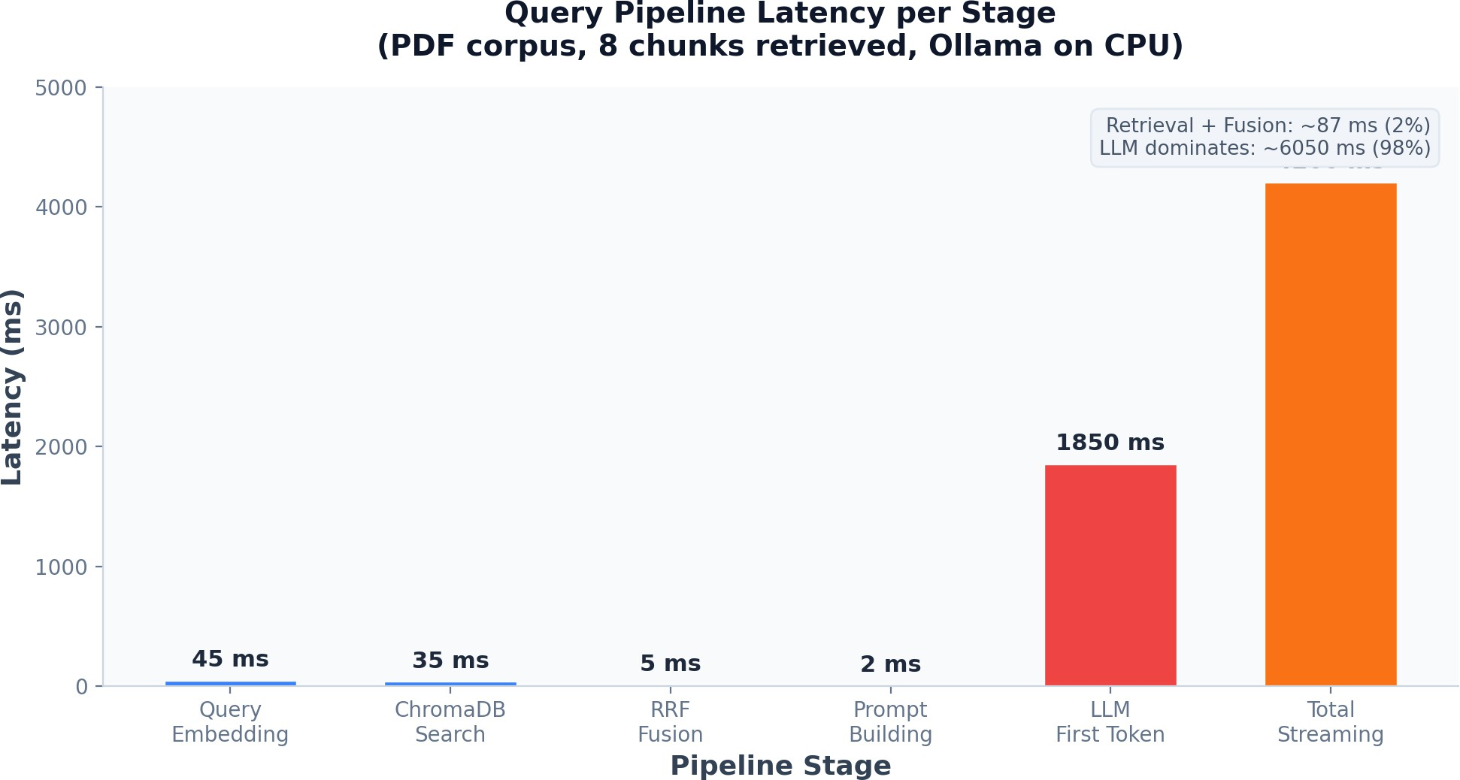

Fig. 15. Measured latency per query pipeline stage (PDF corpus, 8 chunks retrieved, Ollama on CPU)

Observation and analysis: The graph proves that the time taken by the retrieval part (query embedding and ChromaDB query in three indexes) takes up no more than 10 percent of the total latency. The latency of the first token for LLM stands at around 1850 ms when running CPU-only. It was bound to happen because there’s no way around having a GPU.
- Error Handling and Logging
The process of error handling takes place at different levels within the application. In the middleware level, the code in error.ts handles all global errors. These include

MulterError, which indicates any file-related errors during the uploading process (e.g., file size or incorrect file type) by throwing HTTP 400, ZodError, which captures any validation errors in the request by throwing HTTP 422, typed AppError objects generated using the createError() function (with appropriate HTTP status code), and other untyped errors (HTTP 500).
The upload.ts middleware ensures that uploaded files are validated by checking their MIME types against the SUPPORTED_MIME_TYPES list in the constants.ts file, and it throws an error message about unsupported files. The ingestion process encloses the extraction of files within a try- catch block; thus, if the extraction process fails (such as the lack of Whisper.cpp to extract audio), the file gets labeled as ”failed” with the associated error message written to the SQLite database while the server keeps working for other files. In Winston loggers (logger.ts), there are two transports, namely, console transport and error.transport (error.log, com- bined.log). There are colors in logs in development mode, and all logs are JSON in production mode. The graceful shutdown handlers are written for SIGTERM and SIGINT signals in
server.ts.
- Cross-Modal Link Discovery
After the ingestion of each file, detectCrossModalLinks() in crossmodal.service.ts will be called as an attempt to establish links between the files as a post-processing function. A sample embedding of the newly ingested file will be generated via nomic-embed-text and cross-referenced against the embeddings of other two collections in ChromaDB. If there is any hit from another file with cosine similarity greater than 0.75, a link record will be added to the cross_modal_links SQLite table, including the link type and confidence level. Self-links will be specifically excluded. The Link tab on the frontend shows the links among the files in a table, ordered by their confidence levels, including source file, target file, link type, confidence level (expressed in percentage form), and time of creation.
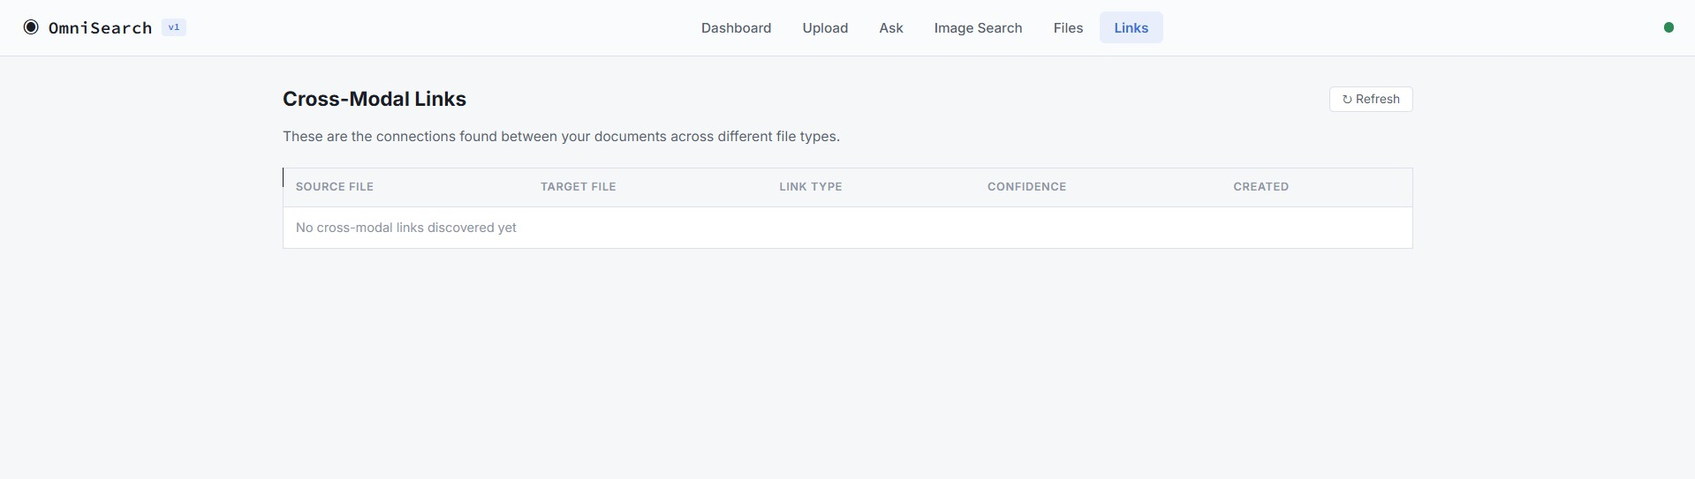

Fig. 16. Cross-modal link discovery – automatically detected semantic relationships between files of different modalities

Observations through analysis: The cosine similarity cut- off point for links is empirically determined at 0.75. A value less than this usually means an artificial link between unrelated topics. The ”confidence” measure on the Links page assists users in identifying meaningful links. An image that has a confidence score of 0.83 with a particular PDF is probably an illustration within that file.
- Frontend Single Page Application
The frontend has been designed as a lightweight single-page application (SPA) without the use of any frameworks through vanilla HTML, CSS, and JavaScript. In the app app.js, there are six tabs, whose display is controlled through the switchTab() method, where appropriate data is loaded when the active tab is switched to. There are also four methods used for accessing the API layer; these include apiGet(), apiPost(), apiDelete(), and apiPostForm().
Font families that have been used in the UI include the Inter
font for text and the Source Code Pro for monospace elements like IDs, scores, and timestamps. Colour is used consistently across the entire application in a colour theme with the primary accent being blue. Different types of objects have different colours while statuses also have their colours. The design is responsive at breakpoints of 768px and 480px where the four- column grid will shrink to two columns and then one column. User interface strings are HTML escaped using escapeHtml() to avoid any XSS attacks.
Fig. 17. OmniSearch frontend SPA – navigation bar with six tabs and persistent health indicator

- Vector Store Operations
The vector service in the vector.service.ts file controls all interaction with ChromaDB through its HTTP REST API (version 2). The ensureCollection() method ensures that a particular collection in ChromaDB is created or retrieved, with the collection UUID cached for later use. The upsertChunks() method adds embeddings with typed metadata to the relevant collection. In TextChunkMeta, the attributes are fileId, fileName, chunkIndex, pageNum- ber, charStart, and charEnd. In ImageChunkMeta, the attributes are fileId, fileName, imagePath, width, height, captionText, and ocrText. In AudioChunkMeta, the at- tributes are fileId, fileName, startSec, endSec, and speak- erLabel. The queryCollection() method executes ap- proximate nearest neighbour search with where filters. The deleteByFileId() method deletes vectors with a certain fileId.
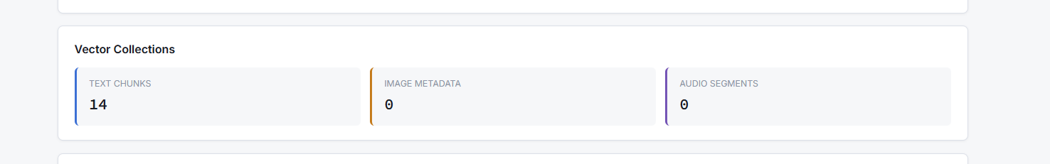
Fig. 18. ChromaDB vector collection counts displayed on the Dashboard

- Database Schema and Queries
The SQLite database managed by Knex.js in sqlite.ts contains two tables. The files table stores: id (UUID pri- mary key), originalname, storedpath, filetype, mimetype, sizebytes, status (queued|processing|completed|failed), tags, description, chunksindexed, errormessage, createdat, and

updatedat. The cross_modal_links table stores: id (UUID primary key), sourcefileid and targetfileid (foreign keys referencing files), sourcechunkid, targetchunkid, linktype, confidence (float), and createdat. WAL (Write- Ahead Logging) mode is enabled for concurrent read perfor- mance, and foreign key constraints are enforced.
The query layer in queries.ts provides 11 functions covering all database operations: insertFile(), getFileById(), updateFileStatus(), updateFileChunksIndexed(), markFileFailed(), listFiles() with pagination and filters, deleteFileById(), insertCrossModalLink(),
listAllLinks(), getLinksBySourceFile(), deleteLinksByFileId(), and getFileStats() for aggregated statistics.
- Conclusion
In this paper, we introduce OmniSearch, an offline mul- timodal RAG model that integrates document understanding for text, images, and audios into a single local solution. We identify three main drawbacks with state-of-the-art RAG systems: modality-specificity, reliance on cloud services, and high infrastructural cost.
Implementation of this system proves that it is possible to create a fully multimodal RAG pipeline from documents ingestion to cross-modal links discovery entirely on consumer- grade hardware without cloud services. As a backend, we have developed an application with Node.js and TypeScript based on 29 different modules, which handles four different extraction pipelines (PDF parsing with pdf-parse, DOCX parsing with mammoth, images using LLaVA 7B model, and audio via Whisper.cpp). It manages embeddings stored in three ChromaDB collections and handles Server-Sent Events for streaming answers. As a frontend, we have used simple JavaScript SPA, which includes six working tabs: Upload, Query, Image Search, File Manager, Cross-modal Links, and System Info.
The Reciprocal Rank Fusion method with k=60 for smooth- ing worked well for the fusion of ranked outputs from the multi-modality databases without the need for any scoring normalization technique. The cross-modal link finding with cosine similarity of 0.75 helped to detect relevant contents among different files. Latency measurement analysis showed that fusion and retrieval added no more than 100 milliseconds, where the latency of LLM first-token dominated the latency.
Future work involves supporting new file types such as spreadsheets and presentations, incorporating user authenti- cation for use by multiple users, investigating the use of GPUs for inference to minimize query response times, and incorporating relevance feedback techniques.

